# Report 2: Project Management Plan (PMP)

## 2.1. Problem Definition

### 2.1.1. Name of this Capstone Project

The official and formal project name is “**Online Medical Consultant System**”. Its abbreviation is **OMCS**.

### 2.1.2. Problem Abstract

This system aims to provide the convenient way for doctor and patient to exchange information (chatting, sharing webcam, attachment).

In order to conduct a high quality consulting based on reliable information. This system helps hospitals to build medical profile template.

With many medical profiles linked to one patient, it’s more easier to extract some common information like immunization, allergy.

### 2.1.3. Project Overview

#### 2.1.3.1. The Current System

Currently, we haven’t found any system provide both online medical profile building and online medical consultant services. Below are some systems provide just single feature:

1. HealthTAP <https://www.healthtap.com/>

*“55,000 doctors. No waiting room.”*

Build an interactive health network, people can access large resources health information. Connect directly with doctors. Doctor can build a great reputation by provide high quality consulting.

1. MDLIVE <https://www.mdlive.com/consumer/choose.html>

“*Get 24/7 access to doctors video or phone!*”

Patient registers as a member of the system and make appointment with consultant. After waiting for an email to confirm, he can have a video meeting with doctor.

1. Alobacsi <http://alobacsi.vn/kham-benh-online.htm>

*“Vì sức khỏe người Việt”*

Search in knowledge base (nearly 100000 questions)

Make question by submit the form

1. Tuvansuckhoe24h <http://www.tuvansuckhoe24h.com.vn/>

*“Chia sẽ cùng chuyên gia”*

Support chatting using yahoo

Ask question for consultants

1. Emedsprofile <http://www.emedsprofile.com/>

*“Your Online Medication & Health Profile”*

Users can build their medical profile based on pre-defined template that contains some information like medication name, dose, directions, medical conditions and allergies.

#### 2.1.3.2. The Proposed System

The main system will be a website. It’s intended for used in one hospital or clinic.

The system will provide the following main features:

* Hospital admin:
  + Define a template for medical profile with high customization, reusable patient information and built-in components.
  + Update hospital information.
  + Manage doctors, patients, specialty fields, film types, allergy types.
  + Manage all created medical profiles.
  + Manage comments from patient.
* Doctors:
  + Manage patient information.
  + Use predefined templates to create medical profile for patient.
  + View conversation history, chat with patient.
  + Request patient to show their webcam.
  + View medical profile template.
* Patients
  + Manage some basic information, health medical record.
  + View their medical profile.
  + Request doctor to get consulted, share webcam, upload attachment.

#### 2.1.3.3. Boundaries of the System

* The system is intended for using in one hospital (we named it as FPT Hospital)
* The language of the system is Vietnamese.
* The complete product includes:
  + The website, for admin, doctor, patient to interactive with system.
  + All the documents, reports during the time develop the system.
* This system in not intended for these aspects:
  + Exporting medical profile.
  + Managing medicine.
  + Managing process of a hospital.

#### 2.1.3.4. Development Environment

#### 2.1.3.4.1 Hardware requirements

**For server**

|  |  |  |
| --- | --- | --- |
| Windows | Minimum Requirements | Recommended |
| Internet Connection | 4Mbps | 8 Mbps |
| Operating System | Window Server 2008 | Window Server 2012 |
| Computer Processor | Intel® Core 2 Duo | Intel® Core(TM) i5 CPU , M 460 @ 2.53GHz |
| Computer Memory | 1GB RAM | 3GB or more |

Table 1: Hardware Requirement for Server

**For Web User**

|  |  |  |
| --- | --- | --- |
| Web | Minimum Requirements | Recommended |
| Internet Connection | 2Mbps | 4Mbps |
| Web Browser | Chrome 22 | Chrome 36 |

Table 2: Hardware Requirement for Web User

#### 2.1.3.4.2 Software requirements

* OS: Microsoft Windows 7.
* Skype: used for communication and meeting
* Google Code & TortoiseSVN: used for source control.
* Website Server: IIS 7 Express
* IDE: Visual Studio 2012
* DBMS: SQL Server 2008 R2
* StarUML 5.0

## 2.2. Project organization

### 2.2.1. System Process Model

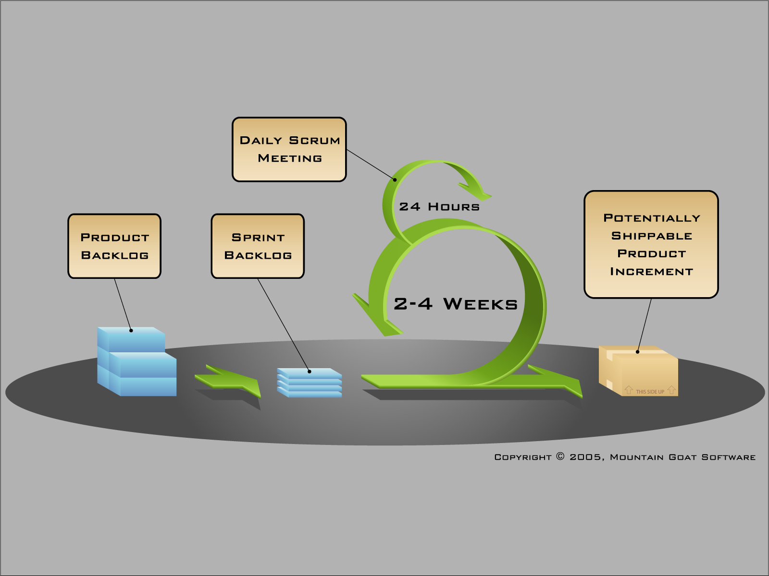

**Figure 1**: General SCRUM Process

### 2.2.2. Roles and Responsibilities

|  |  |  |
| --- | --- | --- |
| Full name | Role in Group | Responsibilities |
| Nguyễn Huy Hùng | Supervisor | * Tracking & managing progress. * Advising Idea & solutions. * Suggesting & supporting in technologies. |
| Trần Nguyên Tiến Sứ | Team Leader, Developer, Business Analyst, Tester, QA | * Tracking & managing progress. * Designing database. * Analyzing requirements. * Planning & scheduling. * Coding. * Testing. * Writing documents & reports |
| Trần Cao Danh | Developer, Business Analyst, Tester | * Analyzing requirements. * Designing database. * Coding. * Testing. * Writing documents. |
| Trương Hải Đăng | Developer, Business Analyst, Tester | * Analyzing requirements. * Designing database. * Coding. * Testing. * Writing documents. |
| Bùi Nguyễn Tín | Developer, Business Analyst, Tester | * Analyzing requirements. * Designing database. * Coding. * Testing. * Writing documents. |

### 2.2.3. Tools and Techniques

Tools:

* Microsoft Visual Studio 2012: Used to implement software modules.
* Microsoft SQL server 2008 R2 Express: Used as the database of the system.
* Microsoft Project: For the team leader to manage tasks of the members and the progress of the project.
* TortoiseSVN: Control source code of the whole project.
* Trello (<https://trello.com/>): Kanban for sprint
* Google Chrome, Firefox: Used to test the system.

Technologies:

* ASP.NET MVC 4
* Entity Framework Model First
* Front-end: Backbone.js, Underscore.js, RequireJS, HTML 5, CSS 3, AJAX, Bootstrap

## 2.3. Project management plan

### 2.3.1. Tasks

### 2.3.2. Task Sheet: Assignments and Timetable

### 2.3.3. All Meeting Minutes

<Put all your-team’s meeting minutes here as an appendix >

## 2.4. Convention Rules

This part requires of recommends certain practices for developing program in the C# language. The object of this coding standard is to have some positive effects:

* Avoidance of errors/bugs, especially the hard-to-find ones.
* Maintainability, by promoting some proven design principles.
* Maintainability, by requiring or recommending a certain unity of style.
* Performance, by discussing wasteful practices.

We will use the coding convention for C#.

<http://msdn.microsoft.com/en-us/library/ff926074.aspx>